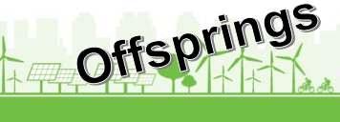

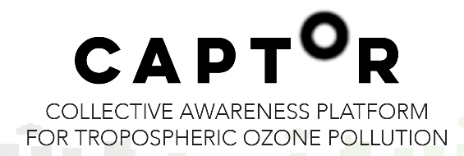
How to become a CAPTOR offspring partner

Questionnaire and requirements check

CAPTOR is a European project, where scientists and citizens in Spain, Italy and Austria join efforts to combat air pollutant. There are several ways you can get active with CAPTOR:
-Measure air pollution at your house (if you live in one of the testbed regions).
-Join discussions and post stories on our community platform.
-Read up to date air-data on our app.
For details please check our website: www.captor-project.eu

Do you want to start a similar project to CAPTOR?
Do you want to get active in the field of air pollution with focus on citizen science?
Are you interested in low cost sensors for data collection? A CAPTOR device costs between 400 and 1000 EUR.
We can give support in the initial phase of your project!

Requirements check

The Captor consortium consist of several organisations with different skills and knowledges. Following requirements should be fulfilled to start your own air quality project as a captor offspring:

*Your organisation should already be involved in:
-air quality OR
-in technical innovation OR
-in citizen science

*You have technical and IT knowledge: One important step is the calibration of the nodes near an existing official measuring station.

*Elaboration of a business model (e.g. by using business model canvas) for the project idea.

Questionnaire

Please answer the following questions.

1.) Are you
- a scientific research institution
- an NGO
- a local community
- a technical innovator
- a private company
- other?

2.) What is your connection to the topic „air pollution“? Do you work in this field?

3.) Why do you want to participate as a captor offspring partner?

4.) Can you describe your idea for an offspring project in a few sentences?

5.) What is your planned target group? Who do you want to address with your project idea?

6.) In order to get support for your project it should start before Oktobe 2018.
Do you already know, when you are planning to start?

How to proceed:

1.) Please return this questionnaire to contact@captor-project.eu or to your personal contact from the CAPTOR contact consortium.
The CAPTOR team will do the evaluation and decide on offspring partners for CAPTOR.

2.) We will ask you to send us your project idea, reflected in a business model.

3.) According to your requirements and geographical setting you will get an offpspring – coach.

4.) 2018 we will give workshops, where you can participate.
We will present the selected partners on the captor webpage.
As an offspring partner you will get the following:
- Handbook(s)
-Advice on financing options for your project.
- Instructions by video
- Access to our captor network
- A starter kit including material for a RAPTOR and/or CAPTOR.
- Support and expertise during the initial phase by an offspring-coach.

Any questions?
Send us an Email: contact@captor-project.eu or contact a national partner in Austria, Italy or Spain. You find all partner-organisations on our webpage:
www.captor-project.eu

